**Step for Assignment Test Execution**

1. To Execute assignment please run below cli command

**node_modules\.bin\cypress run --spec "cypress\integration\examples\bayzattest.js"**

1. Before running this make sure bazat application doesn’t have any employee with ‘testbayzatapplication@gmail.com’, in case it is present, please delete them manually.
2. Execution is set with video recording (check bayzattest\cypress\videos folder)

**Defects -**

For each defect and observation please do refer Defects.docx.

**Step to perform if Gmail integration token is expired or not working**

1. Run cli command - **node node_modules\gmail-tester\init.js cypress\plugins\credentials.json cypress\plugins\gmail_token.json** [**testbayzatapplication@gmail.com**](mailto:testbayzatapplication@gmail.com)

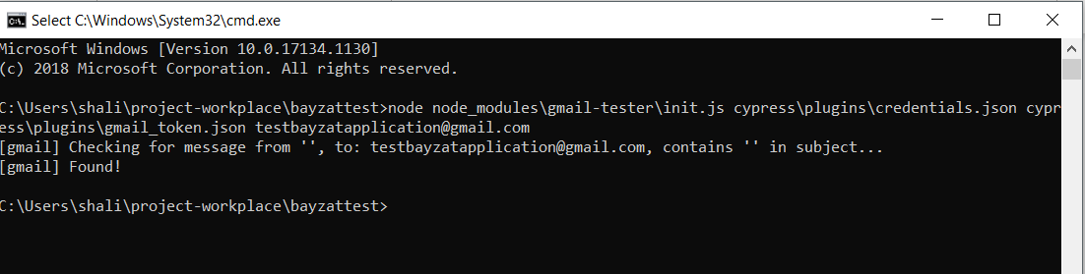

1. To check working email integration run “cypress\integration\examples\CheckGmailIntegration.js” file